DATA SCIENCE MINOR PROJECT
PROJECT REPORT
(Project Semester January-April 2026)
Analysis of Mental Health Care in the Last 4 Weeks Using Python
Submitted by : Aryan Raj Singh
Registration No. 12416105
Programme and Section: K24FC
Course Code: INT375
Under the Guidance of :
Ms. Dr. Baljinder Kaur
Assistant Professor
Discipline of CSE
Lovely School of Computer Science & Engineering
Lovely Professional University, Phagwara

CERTIFICATE
This is to certify that Aryan Raj Singh, bearing Registration no. 12416105 has completed DSMP2025 project titled, “Analysis of Mental Health Care in the Last 4 Weeks Using Python” under my guidance and supervision. To the best of my knowledge, the present work is the result of his original development, effort and study.
Signature and Name of the Supervisor
Designation of the Supervisor
School of Computer Science & Engineering
Lovely Professional University
Phagwara, Punjab.
Date:

DECLARATION
I, Aryan Raj Singh, student of B.Tech CSE under CSE Discipline at Lovely Professional University, Punjab, hereby declare that all the information furnished in this project report is based on my own intensive work and is genuine.
Date: 08-04-25
Signature – Aryan Raj Singh
Registration No. 12416105
Name of the student: Aryan Raj Singh

1. Introduction
Mental health has emerged as a critical public health issue, especially in the post-pandemic era. This project performs an Exploratory Data Analysis (EDA) on a dataset titled "Mental Health Care in the Last 4 Weeks." Using Python and its powerful libraries like Pandas, NumPy, Seaborn, and Matplotlib, the project extracts insights into trends, patterns, and demographic distributions of mental health service utilization.

2. Dataset Description
- Dataset Name: Mental_Health_Care_in_the_Last_4_Weeks.csv
- Source: Data.Gov / U.S. Census Bureau
- Format: CSV
- Size: ~200 KB
- Rows: 10405
- Columns: 15

3. Tools and Technologies Used
- Python
- Pandas
- NumPy
- Matplotlib
- Seaborn

4. Methodology

4.1 Data Loading and Preparation
- Loaded the dataset using pandas.read_csv().
- Converted the 'Time Period Start Date' column to datetime format.
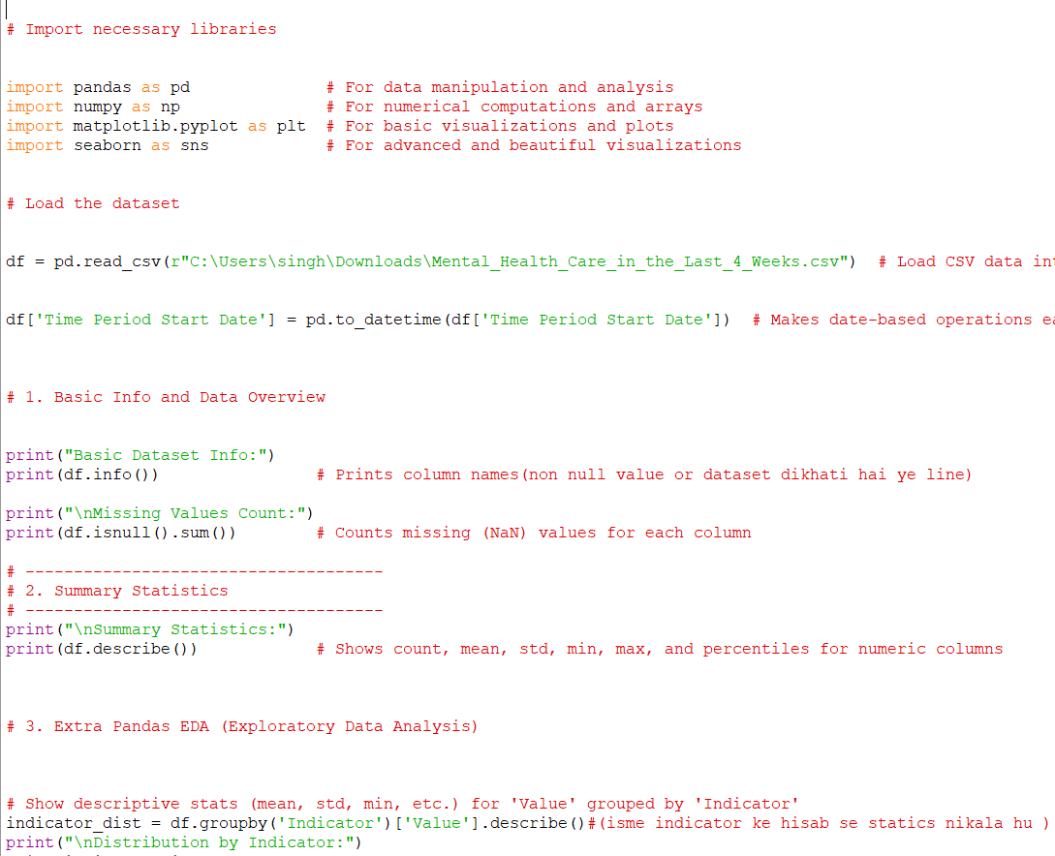

4.2 Data Overview
- Used df.info() to understand structure and types.
- Counted missing values using df.isnull().sum().
- Displayed summary statistics with df.describe().
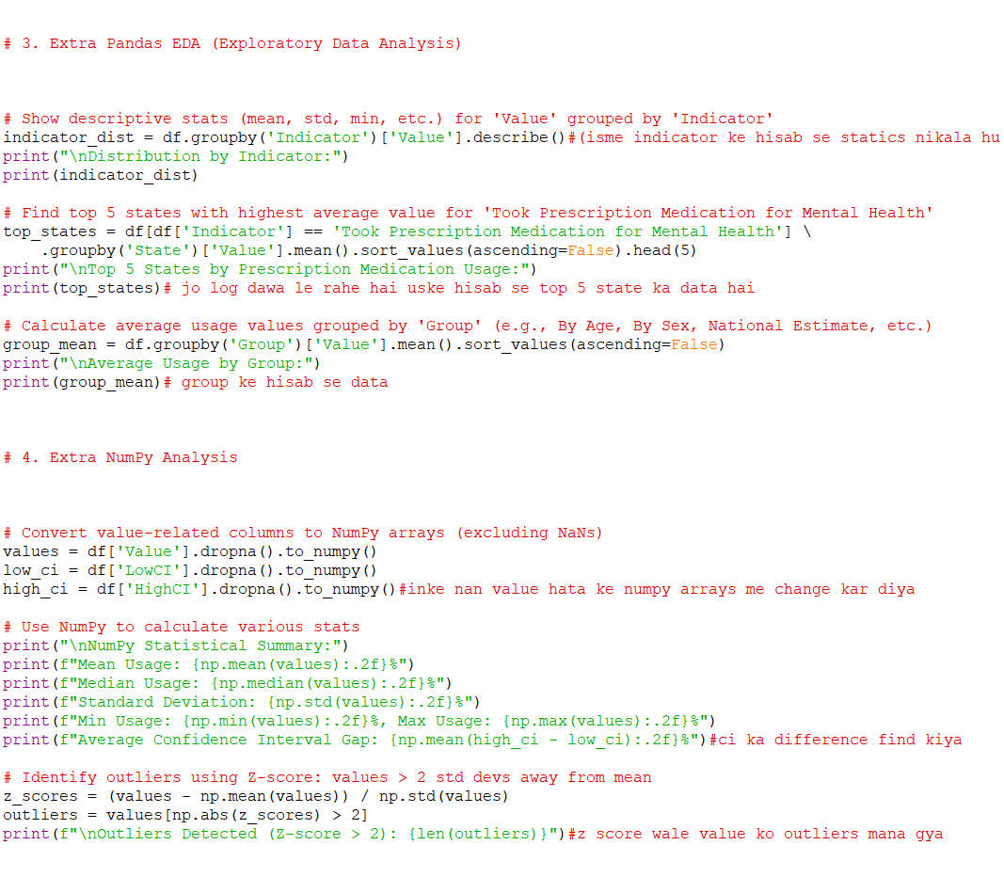

4.3 Exploratory Data Analysis
- Grouped and described data by indicator.
- Identified top states with highest prescription medication usage.
- Computed average values across different demographic groups.

4.4 NumPy Analysis
- Converted relevant columns to NumPy arrays.
- Calculated mean, median, standard deviation, min, max, and confidence interval gap.

4.5 Visualizations
- Correlation heatmap of numeric features.
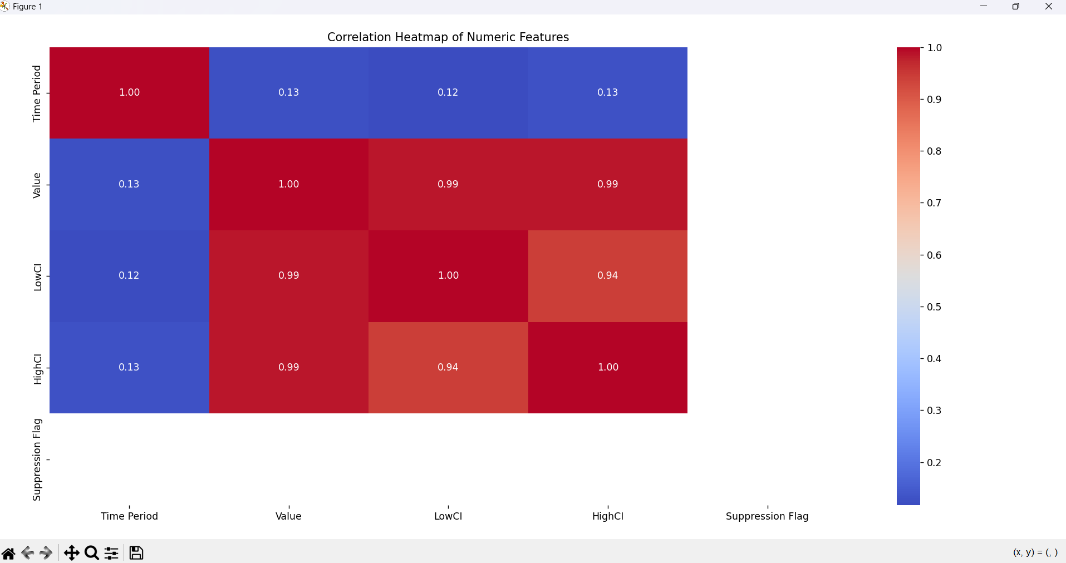

- Line plot of national mental health trends over time.
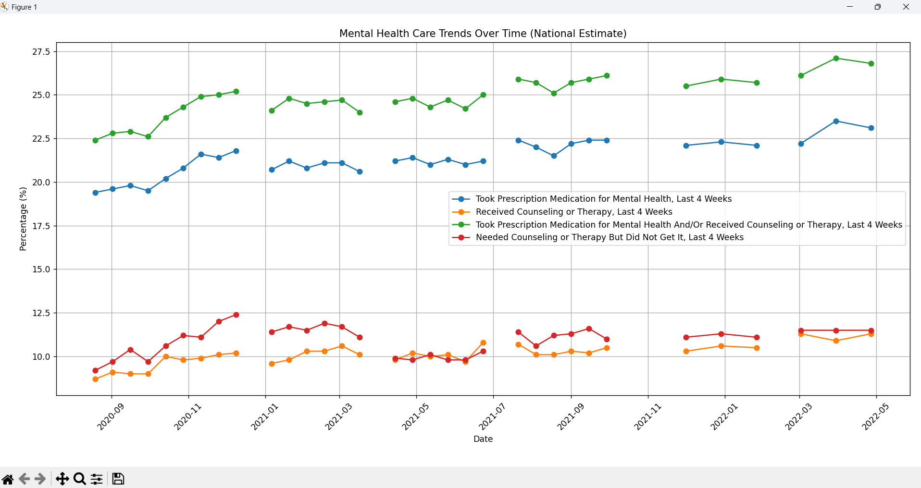
- Bar plots comparing demographic groups and states.
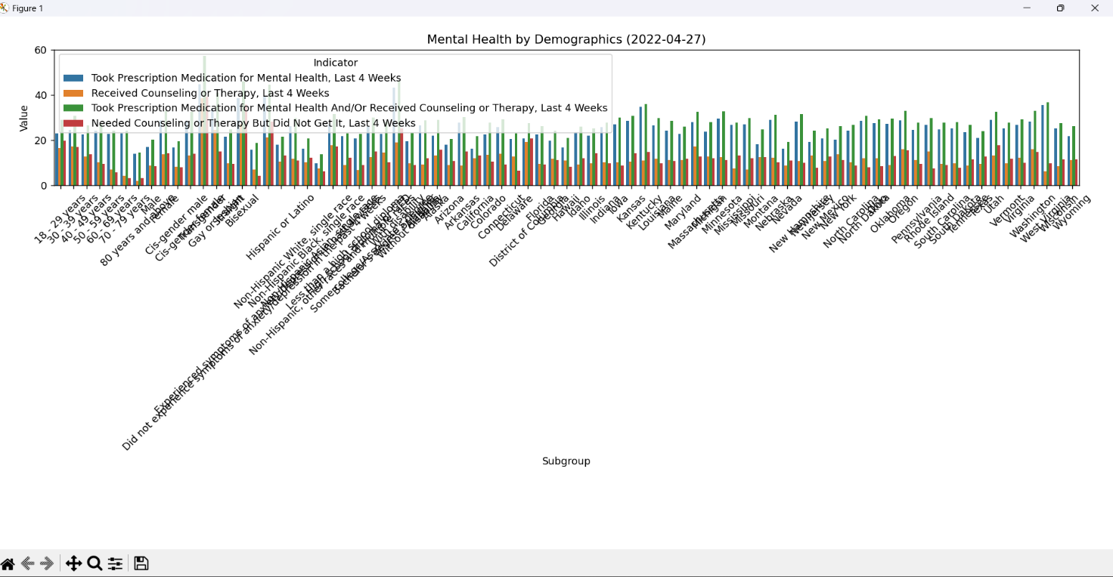

- Error bars for confidence intervals by age group.
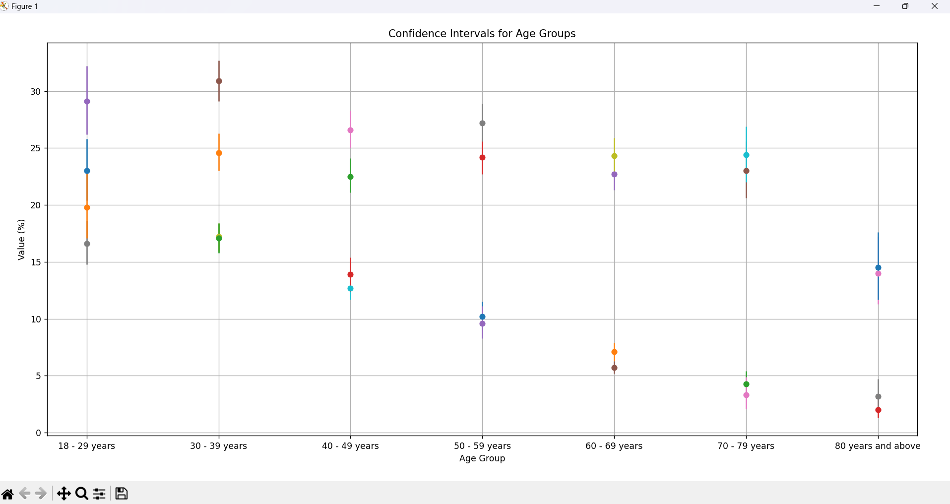

- Time series plot for 18–29 year olds.

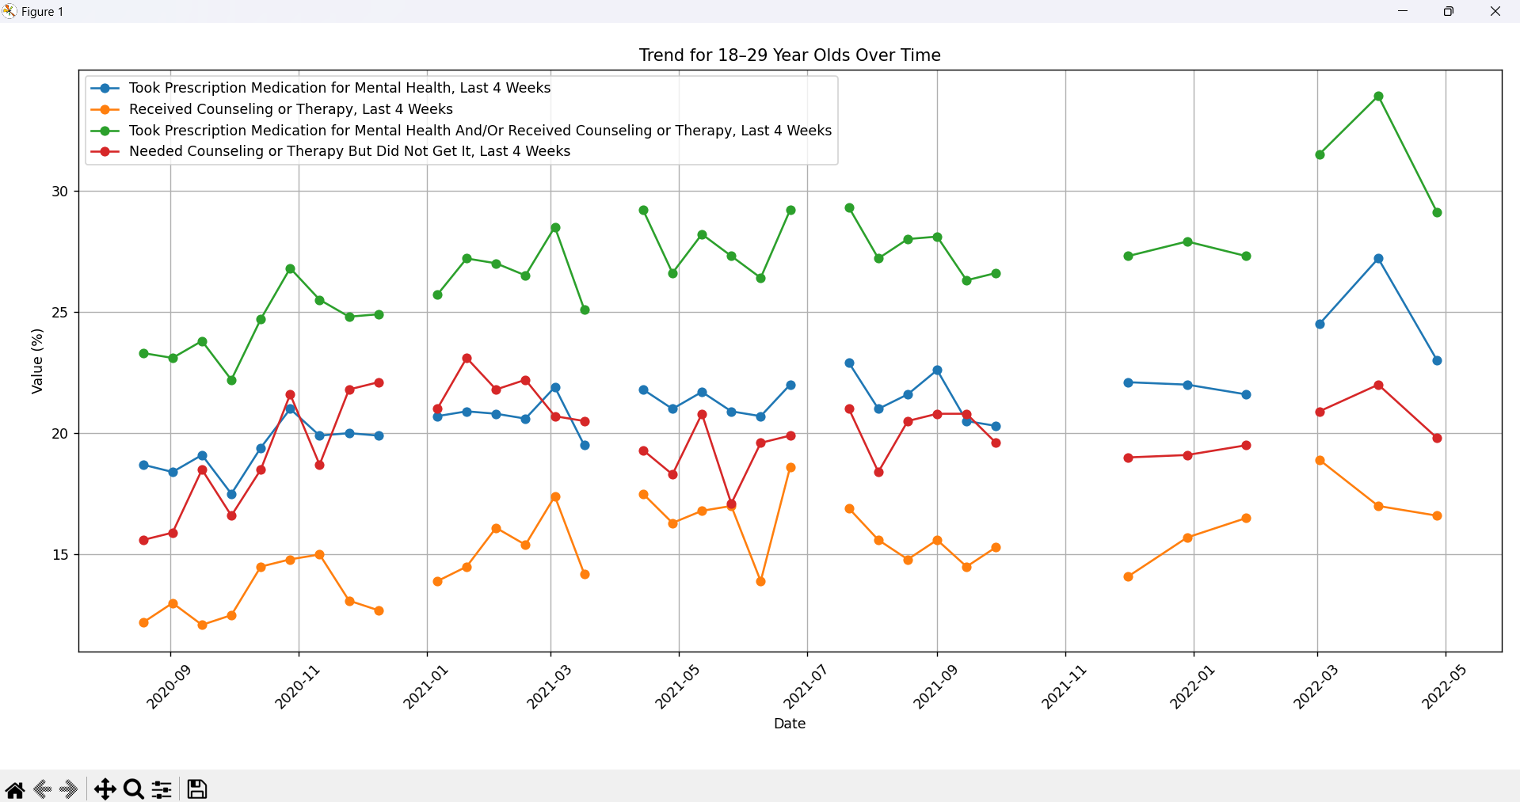

5. Key Insights
- Missing Values: Present in multiple columns, especially confidence intervals.
- National Trends: Indicators show fluctuating usage patterns across time.
- Top States: Some states show consistently higher usage of mental health services.
- Demographic Breakdown: Significant variation among age, sex, and race.
- Correlation Analysis: Moderate correlations found between some numeric variables.

6. Conclusion
This project successfully performs an exploratory analysis of mental health care access data. It highlights demographic disparities, identifies states with high prescription usage, and shows trends over time. Visualizations provide an effective medium for understanding the data.

7. Future Scope
- Implement machine learning models for prediction.
- Integrate external datasets (e.g., socioeconomic or health infrastructure).
- Apply time-series analysis for deeper temporal trends.

8. References
- U.S. Census Bureau
- https://pandas.pydata.org/
- https://numpy.org/
- https://matplotlib.org/
- https://seaborn.pydata.org/

